**Task 02**

**Task 03**

**Task 04**

**Task 05**

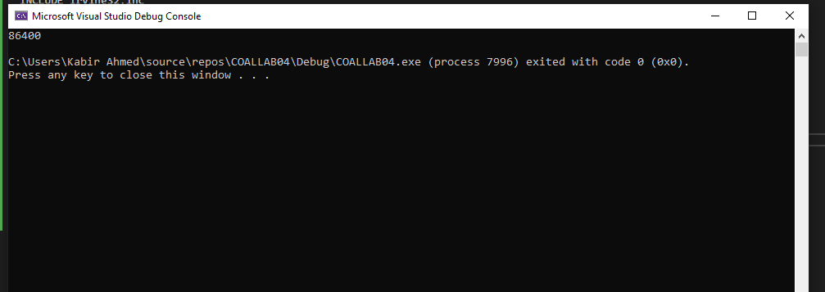

**Task 06**

**Task 07**

